# Testing of Unitree A1 motor

Unitree A1 motor’s encoder, velocity and torque properties were tested to check whether the motor meets requirements of this project’s humanoid robot.

To ensure appropriate health and safety standard velocity, torque and current tests were conducted in a cage inside which nobody was allowed when the motor was connected to a source of power. Additionally, a safety button was connected in series between power source and the motor.

## Encoder testing

To control movement of humanoid limbs a precise position of a limb is needed. This information can be provided by Unitree A1 motor’s built-in encoder but to ensure that it can provide readings of sufficient precision it must have been tested.

### Setup

The accuracy of the encoder was tested by placing the motor with attached to the rotor pointer in a centre of a printed protractor as presented in Figure 1.

The motor was set to no torque mode which allowed for free rotation of the pointer by hand. Additionally, the actual output of the encoder was divided by 9.1 due to the internal gear ratio of the motor, so that the recorded values were consistent with protractor’s indication.

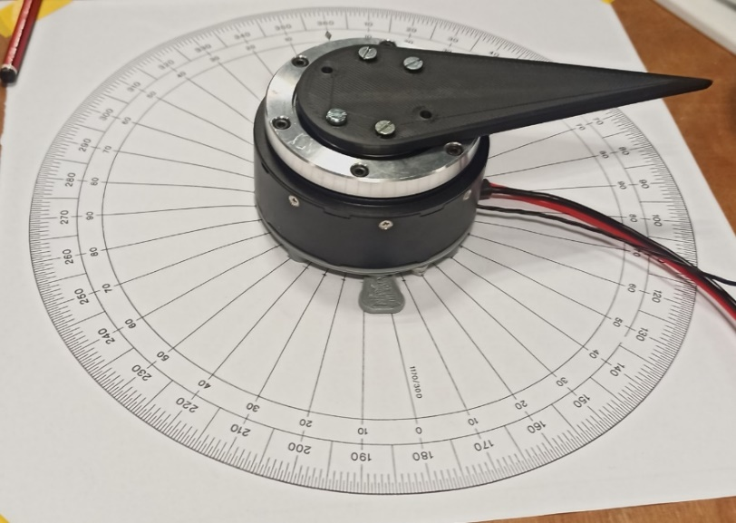

Figure 1 Encoder testing setup

### Steps

Initially, rotor’s position was aligned with the protractor so that both indicated 90°. Then the rotor was moved ten times by 180° to verify the accuracy of repeated movement which was followed by 11 full revolutions and two more 180° rotations to check whether the error is affected by the magnitude of a move. The remaining readings were verifying whether the error changes for small rotations. The recorded values are presented in Figure 2.

|  |  |  |  |  |
| --- | --- | --- | --- | --- |
| Reading number | Done motion [°] | Encoder reading [°] | Protractor [°] | Error [°] |
| 1 | Initial position | 90 | 90 | 0 |
| 2 | 180 | 270.068 | 270 | 0.068 |
| 3 | 180 | 449.097 | 450 | 0.903 |
| 4 | 180 | 630.442 | 630 | 0.442 |
| 5 | 180 | 808.899 | 810 | 1.101 |
| 6 | 180 | 990.307 | 990 | 0.307 |
| 7 | 180 | 1168.976 | 1170 | 1.024 |
| 8 | 180 | 1350.956 | 1350 | 0.956 |
| 9 | 180 | 1528.826 | 1530 | 1.174 |
| 10 | 180 | 1710.626 | 1710 | 0.626 |
| 11 | 180 | 1888.916 | 1890 | 1.084 |
| 12 | 3960 | 5848.556 | 5850 | 1.444 |
| 13 | 180 | 6030.426 | 6030 | 0.426 |
| 14 | 180 | 6208.576 | 6210 | 1.424 |
| 15 | 90 | 6299.016 | 6300 | 0.984 |
| 16 | 30 | 6330.036 | 6330 | 0.036 |
| 17 | 60 | 6390.196 | 6390 | 0.196 |
| 18 | 270 | 6659.426 | 6660 | 0.574 |

Figure 2 Recorded outputs of encoder and protractor readings.

### Discussion of encoder test results

Errors between protractor indications and encoder readings are mostly affected by the difficulty of precise positioning of the rotor’s pointer on the protractor because of the torque required to move the rotor that was slightly dropping once the rotor was moving which caused overshooting. Additionally, rotor’s position could have been measured with precision of up to 1° as that was the resolution of the protractor.

The average value of the errors amounted to 0.75°, with the maximum error of a single measurement equal to 1.4°. Such result of the test lies within a reasonable tolerance considering sources of error that the test was burdened with as described above. This proves that motor’s encoder is suitable for indicating positions of humanoid’s limbs with sufficient precision.

## Velocity testing

Humanoid robot’s limbs must move with enough speed to perform swift movements. To make sure that Unitree A1 motor can reach maximum desired velocity at a torque mimicking motion of a limb a velocity test was performed. Therefore, flexion of the designed arm at the speed of 1 rpm generating 0.8 Nm was taken as a point of reference.

### Test setup

Due to limited components suitable for imitating of the arm, test torque was increased to 1.12 Nm. It was exerted by an attached to the rotor lever when in parallel to the ground position (Figure 3).

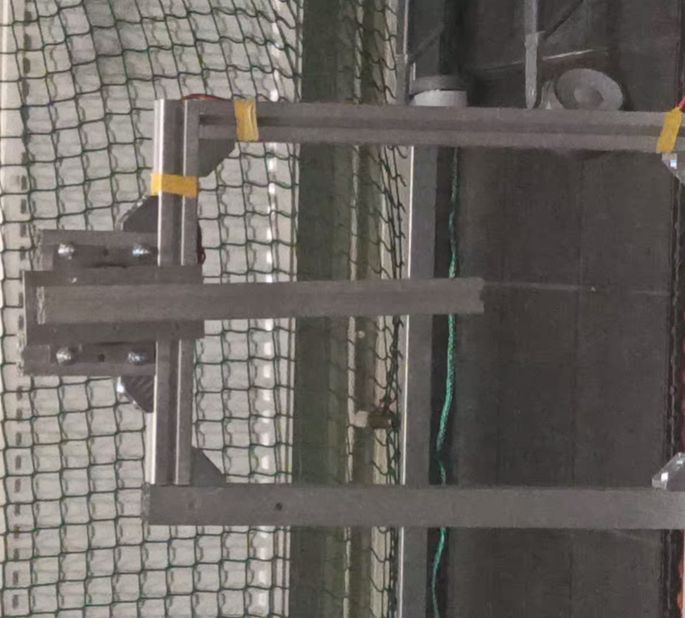

Figure 3 Velocity test setup

### Steps

The motor was gradually accelerated to the maximum desired velocity of 2π rad/s which was then maintained for a few seconds. Motor’s velocity was calculated from a video of the test by multiplying number of frames per rotation by the inverse of frame rate of the camera equal to 60 fps (Figure 4).

|  |  |  |  |  |
| --- | --- | --- | --- | --- |
| Start time of a rotation [s] | End time a rotation [s] | Time difference [s] | Average velocity of a rotation [rad/s] | Error between desired and measured velocity [rad/s] |
| 5.832 | 6.865 | 1.033 | 6.082 | 0.200 |
| 6.865 | 7.898 | 1.033 | 6.082 | 0.200 |
| 7.898 | 8.931 | 1.033 | 6.082 | 0.200 |
| 8.931 | 9.964 | 1.033 | 6.082 | 0.200 |

Figure 4 Motor's velocity measured using a camera

### Discussion of velocity test results

The test was burdened with measurement inaccuracies such as the frame rate of the camera which limits the precision of the measurement to 0.017s as well as difficulty in precise identification of the moment when a full rotation was completed. These factors contributed towards obtaining the difference between desired and measured speed.

Values obtained from the video of the test (Figure 4) show that the Unitree A1 motor is capable of stable running close to the desired speed at the applied torque. The error is consistent throughout the duration of the test and equal to 3% which is a satisfactory result. The reason for the velocity difference could be a varying torque acting on the motor due to the constantly changing angle between the centre of the mass of the lever and gravitational acceleration.

## Torque testing

One of the key information in the design of an actuation mechanism of a humanoid robot is the amount of available torque. Therefore, a test evaluating the maximum torque of the Unitree A1 motor was designed and performed.

### Test setup

A lever was attached to the rotor, so that an additional mass generating required torque could have been hanged on it. To ensure that the lever was in a parallel to the ground position in the beginning of the test, which maximised generated torque and simplified its calculation, a beam cut to an appropriate length was used as a support which was removed once the motor was powered up (Figure 5). A proportional controller was used for the control of the motor during the test.

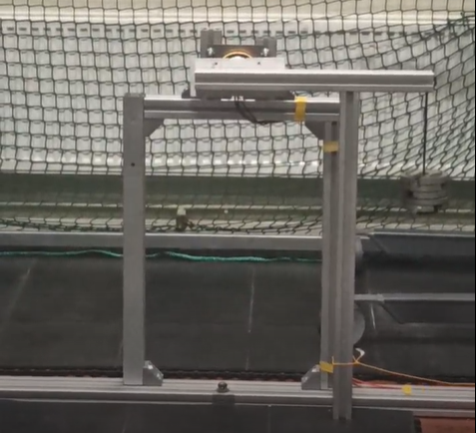

Figure 5 Torque test setup

### Steps

To minimise risk of breaking the motor the test had multiple iterations between which proportional controller gain was increased until the motor was not letting the lever to rotate downwards. Once that was achieved the mass at the end of the lever was increased and controller’s gain was iteratively increased again. This process continued until the maximum torque of the motor was achieved.

The torque was calculated by measuring length of the lever and its mass as well as by weighting the additional mass attached to it. These values allowed for estimation of the torque experienced by the rotor considering lever’s deviation from the horizontal position due to the acting torque. The calculated value was then compared to the torque reading from the motor.

The maximum torque was calculated considering inertia of the setup and deviation angle from horizontal position once the motor stabilised and amounting to 0.65 rad (Figure 7). The calculated torque equals to 32.5 Nm. Motor’s torque sensor output indicated 33.5 Nm (Figure 6).

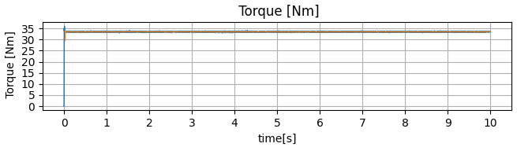

Figure 6 Output of motor's torque sensor at the maximum torque.

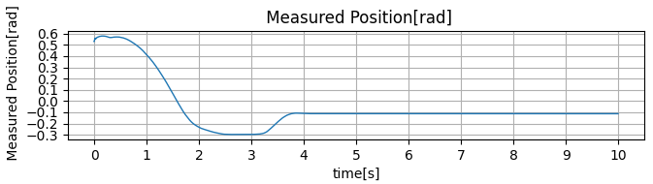

Figure 7 Output of motor's encoder at the maximum torque test

### Discussion of torque test results

The test was burdened with measurement inaccuracies such as 0.01 kg resolution of the scale used for weighting the lever and additional weights, obtained above motor’s encoder average reading precision of 0.75° used for determining the deviation from the horizontal position as well as difficulty in precise measuring of the distance between the weight’s point of attachment and centre of rotation. Moreover, assumption that initial position of the lever is horizontal in every iteration introduced additional inaccuracy.

The maximum torque of the motor obtained in the test equals to 32.5 Nm and differs from the datasheet value of 33.5 Nm by 1 Nm. This equals to 3% discrepancy, which places the result within a satisfactory margin of error.

## Maximum current testing

A Permanent Magnet Synchronous Motor (PMSM) such as Unitree A1 motor is characterised by a linear correlation between torque and current hence to design a wiring loom of appropriate current rating current drawn at maximum torque must be determined.

### Test setup and steps

Setup, test steps, measurements and calculations for the drawn current testing are identical as for the torque testing described above with addition of recording current drawn by the motor with a clamp meter.

Figure 8 Torque vs current characteristic of the motor.

### Discussion of torque test results

Apart from the source of error discussed in torque testing section above, this test was additionally burdened with notable imprecision of the current reading. It had a lot of noise and positive offset of approximately 0.25 A when compared with the reading from the power supply for currents below 4 A. However, the test itself was supposed to provide only a point of reference of the maximum current value for the current rating of a wiring loom for the motors. Therefore, such large inaccuracies of the test are acceptable.

Obtained curve of current vs torque characteristics (Figure 8) resembles a straight line as it is expected for a permanent magnet synchronous motor such as Unitree A1 motor (<https://ieeexplore.ieee.org/stamp/stamp.jsp?tp=&arnumber=25541> + power electronics book). The maximum current that occurs at maximum torque is estimated to be 20 A. Therefore, the wiring loom should be designed to operate above this value.